**Allotment Details**

Price could be in decimal

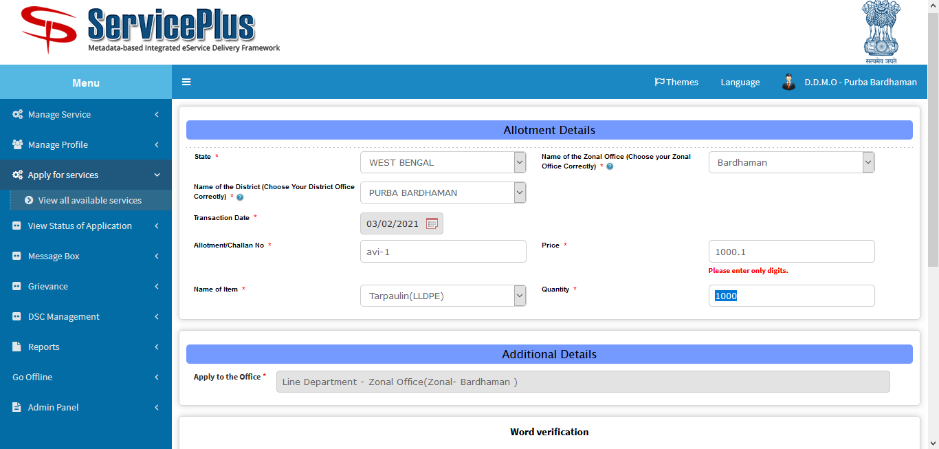

After successful allotment, list of item is still enabled.

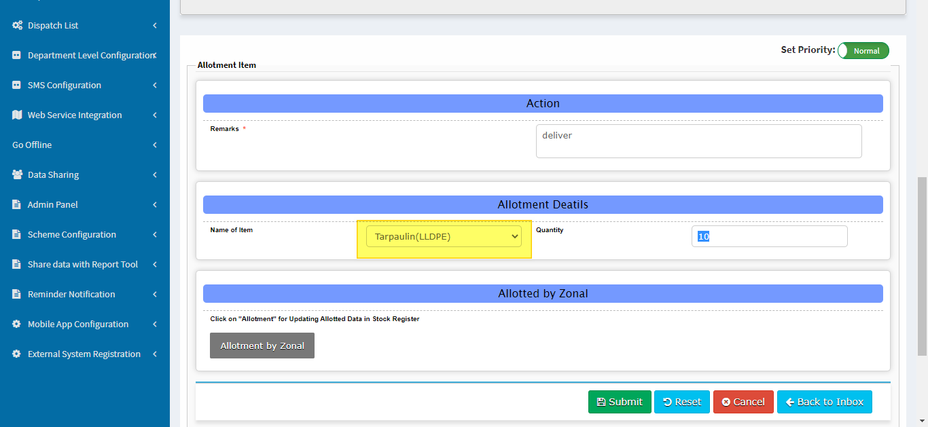

Cant able to scan qr code

